Testing

Christian Munoz, Sean Gold, Elliot Parker

Table of Contents

Table of Contents 1

Logical Testing 2

Case 1 3

Case 2 4

Failure Avoidance Measures 5

Transferring to the Wix content management platform 6

Extra Security 6

Using a Static Site 6

# Logical Testing

## Case 1

Case 1 involves the client – either a user or an administrator – encountering an Error-404 page. Error 404 is a HTTP status code and a client-side issue indicating the requested URL can’t be found on the web server. When creating our website in Wix there were some instances where we ran into this error. Specifically, after creating a new page in Wix if the page was not properly linked to the previous page, an Error 404 page would be displayed. Figure 1 shows an image of the Wix Error-404 page.

Figure 1. *Error-404 Page*

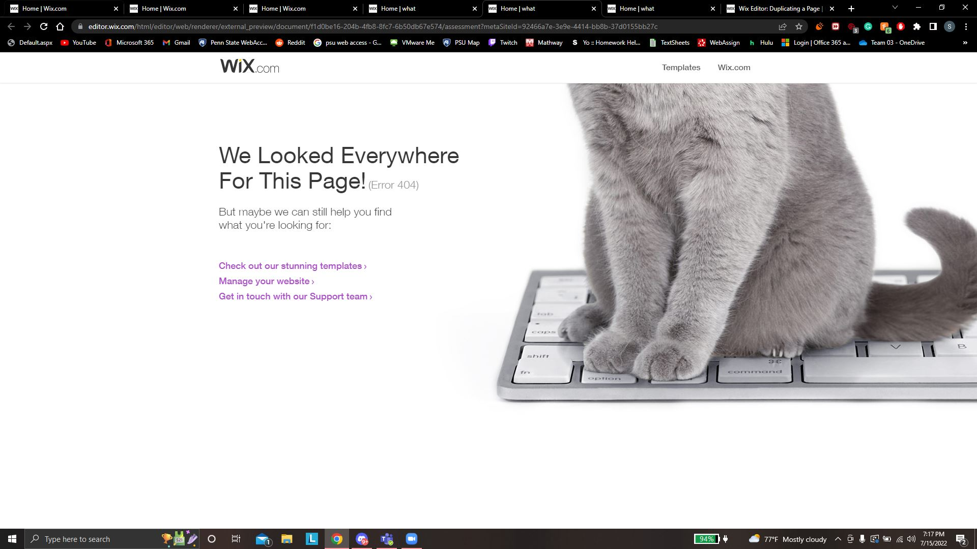

Another easy way to run into Error 404 is to simply incorrectly type in the URL on the User-side. The Error 404 status code is then displayed letting the user know that the website with this URL does not exist.

An easy way to fix error 404 from happening is to redirect the page to the correct one. This can be done using a 301 redirect which is a response code that signals the browser that the original content has been transferred to a different URL. It almost works like autocorrect, the browser knows what page you are trying to reach and redirects you to that page instead. Figure 2 shows the Wix setting page for creating URL redirects.

Figure 2. *301 Redirect Manager*

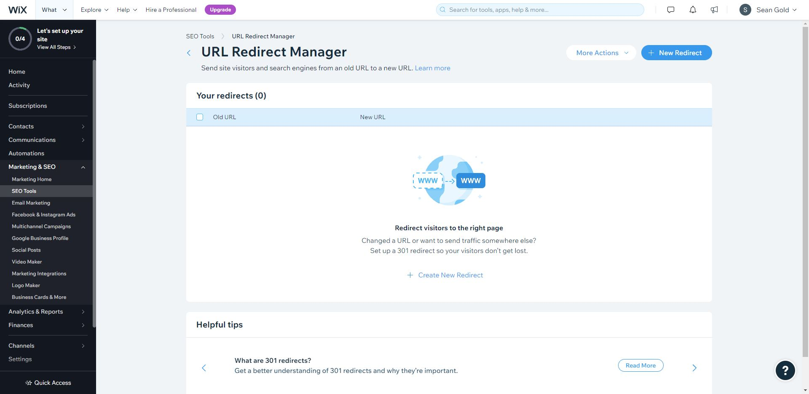

## Case 2

Case 2 involves a user interacting with a button during the assessment. There is the possibility of a button being improperly linked, or not working the right way. If the button is not linked to the correct page, the assessment will not be accurate for the user. If the button is not linked to a page, or linked to an inaccessible page, it will navigate back to the home page. Figures 3, 4, and 5 demonstrate this phenomenon. This is an issue because the assessment can be long, and a user will not want to have to complete the assessment the same way again. This can be avoided with both our comprehensive use testing and individual link checks for each button as well. Figure 6 shows the interaction for checking which page each button is linked to.

Figure 3. *Start of Assessment.*

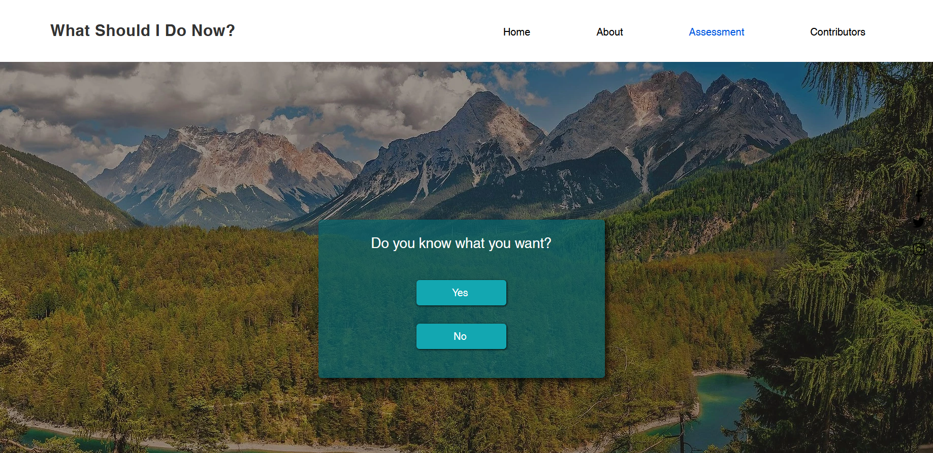

Figure 4. *Assessment page with broken button*

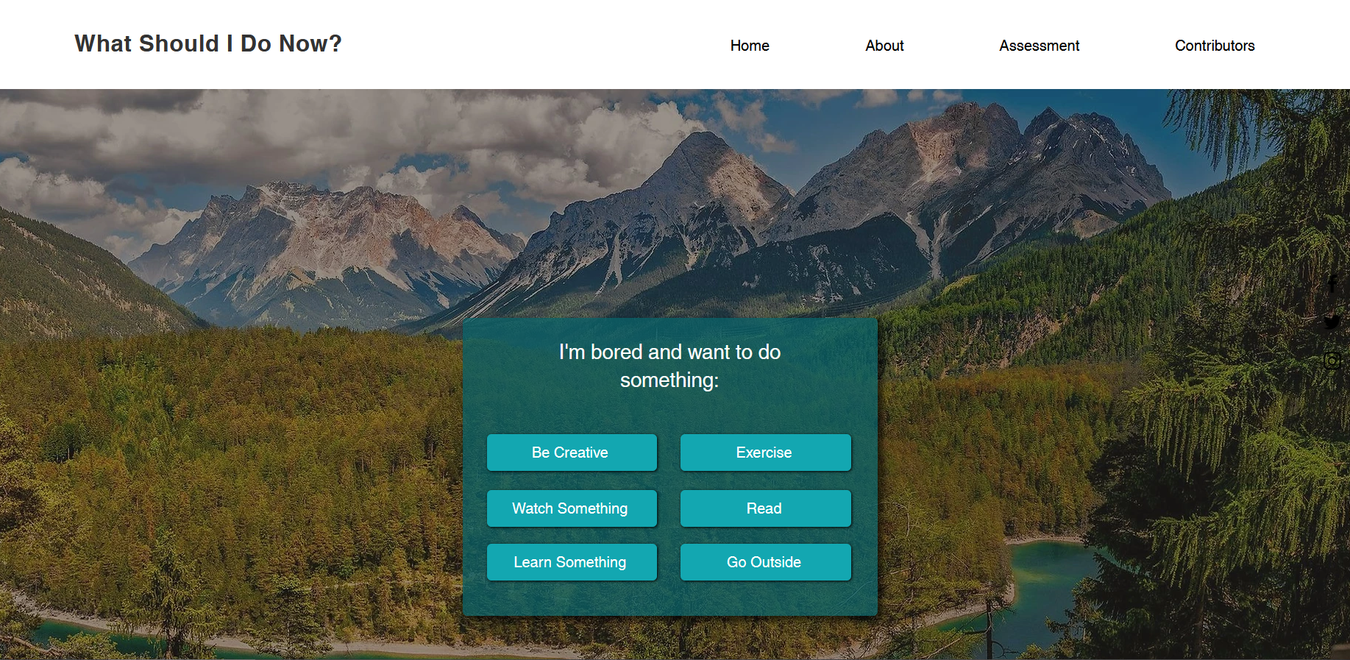

Figure 5. *Site Home page after clicking broken button*

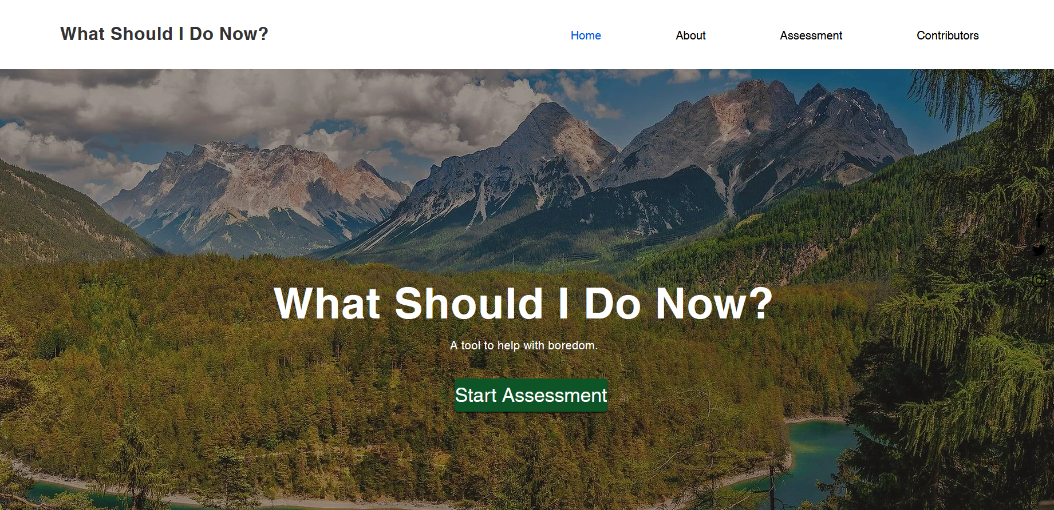

Figure 6. *Link editor for a button* 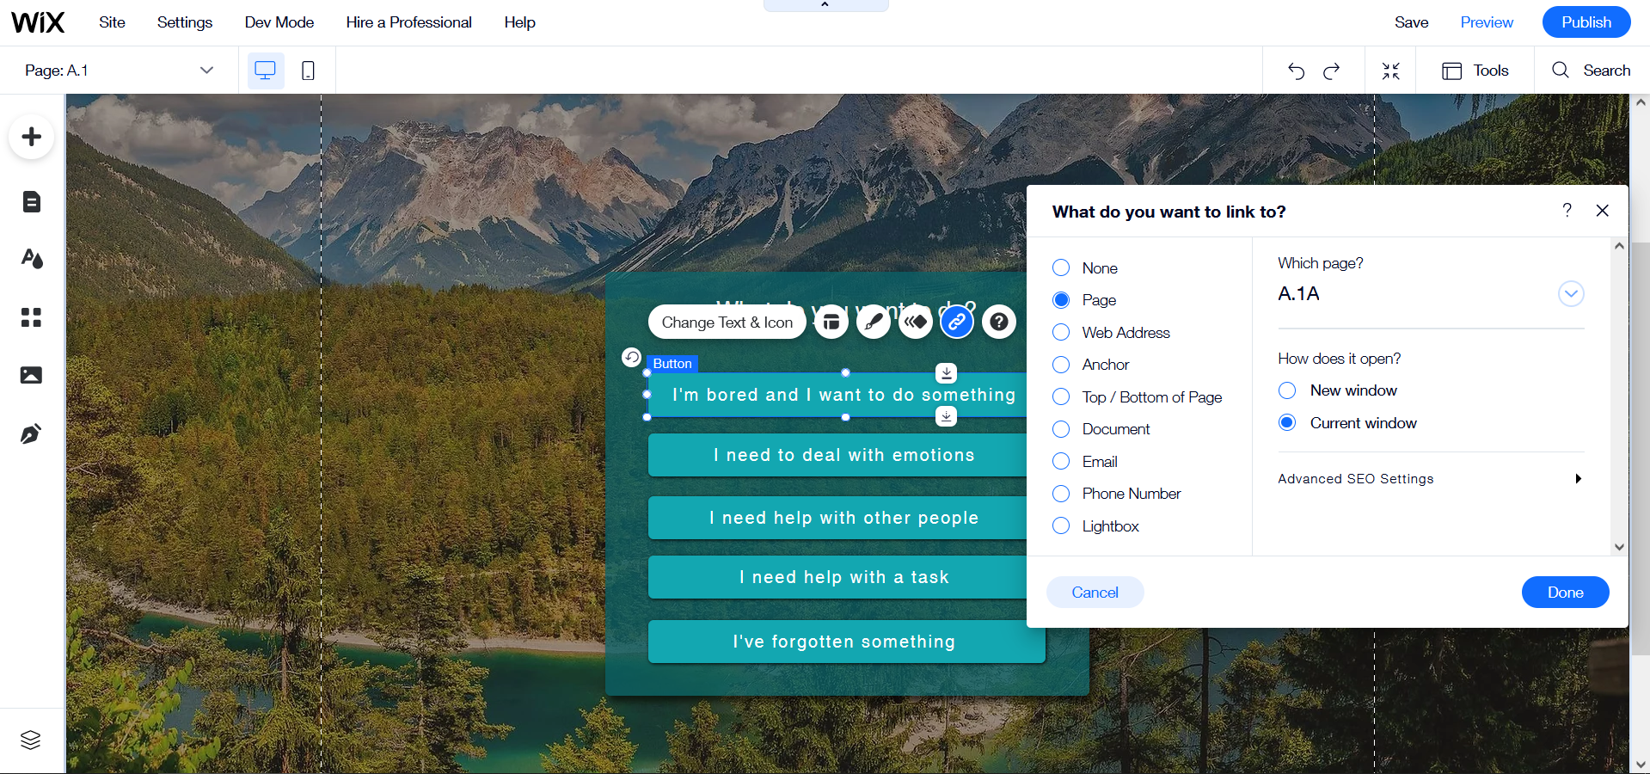

# Failure Avoidance Measures

Transferring to the Wix content management platform

A perk of using a cloud-based web development service like Wix is that we don’t have to worry about server uptime or security issues because it is already built into the website. We don’t have to use on-site hardware that could cost thousands of dollars to host a server and configure it to our liking which would take lots of time. We don’t have to deal with troubleshooting any issues if the server happens to go down, either. The service provider is responsible for the upkeep and maintenance of the infrastructure.

### Extra Security

One of the biggest things to take into consideration when creating anything on the internet is security. Wix adds an extra layer of protection in the form of 2FA. 2FA goes beyond the standard username and password to login. It requires additional login credentials in the form of something belonging to you. An example could be a one-time password sent to your mobile device. By having all site admins use this additional security to log in, we are ensuring that our data and our users are as safe as possible.

### Using a Static Site

Another reason we opted to use Wix instead of creating our own was the reliability of a static website. For a website that isn’t very complicated like ours, not having to connect to a database to retrieve data is more reliable because we don’t have to rely on a separate program to operate the website. We don’t have to worry about connections or changes to a dynamic database either. It also adds to the security of the website because there are less links in the chain where things can be overlooked. Keeping the data contained within the site itself is more secure since there are fewer points of access as well.